🌐 What is WebRTC?
WebRTC = Web Real-Time Communication
It is a browser technology that allows:
- 🎤 Voice calls
- 🎥 Video calls
- 💬 Real-time data
👉 Directly between users,
👉 Without installing any app or plugin,
👉 For free.
It works in Chrome, Edge, Firefox, Safari, and mobile browsers.

🔑 Why WebRTC is IMPORTANT for Your GD App
Because WebRTC:
- is free
- uses low bandwidth
- works in browser
- supports voice-only
- is used by Zoom, Google Meet, Jitsi
👉 Without WebRTC, voice GD is impossible
🎧 WebRTC in Voice Group Discussion (Your Case)
What WebRTC handles
- Microphone access
- Live voice streaming
- Echo cancellation
- Noise reduction
What YOUR app handles
- Topic
- Prep time
- Grouping
- Turn-based speaking
- Scoring
👉 WebRTC = voice pipe
👉 Your app = brain
You are NOT building WebRTC from scratch.
You will:
- Build your job portal logic
- Plug in Jitsi as a voice engine
- Control it programmatically
Think of Jitsi as:
“Just a microphone + speaker layer inside my app”
STEP 1: DECIDE INTEGRATION MODE
You have 2 choices:
✅ OPTION A (RECOMMENDED)
Self-host Jitsi + Embed via IFrame API
✔ Full control
✔ Free
✔ Automation possible
STEP 2: SET UP JITSI (ONE-TIME)
Minimum Setup (Free)
- Use Oracle Cloud Free Tier or local VM
- Install Jitsi using official script
You’ll get:
https://voice.yourdomain.com
This is your private voice engine.
📌 You do this once, not per GD.
STEP 3: BACKEND – CREATE VOICE GD SESSION
Your backend controls:
- who joins
- when it starts
- room name
Example (Node.js)
function createVoiceGDRoom(topic) {
return `gd_${topic}_${Date.now()}`;
}
Store in DB:
roomName
topic
users[]
startTime
endTime
STEP 4: FRONTEND – PREPARATION SCREEN
Before voice starts:
- Show topic
- Give prep time (10–20 min)
- Explain rules
NO Jitsi loaded yet.
This avoids:
- bandwidth waste
- premature mic access
STEP 5: EMBED JITSI (CORE INTEGRATION)
React Example
const domain = "voice.yourdomain.com";

const options = {
roomName: roomNameFromBackend,
width: "100%",
height: 500,
parentNode: document.getElementById("jitsi"),
configOverwrite: {
startWithAudioMuted: true,
startWithVideoMuted: true,
disableVideo: true
},
interfaceConfigOverwrite: {
TOOLBAR_BUTTONS: []
}
};

const api = new window.JitsiMeetExternalAPI(domain, options);
✔ Audio only
✔ Video removed
✔ Clean UI

🧠 STEP 6: AUTOMATED TURN CONTROL (VERY IMPORTANT)
This is what makes it GD, not chaos.
Backend decides speaking order
User A → User B → User C → Open Round
Frontend executes commands
api.executeCommand("muteEveryone");
api.executeCommand("toggleAudio"); // for active speaker
You control:
- who speaks
- for how long
- when to mute

⏱️ STEP 7: CAPTURE DISCUSSION DATA (NOT AUDIO)
You do NOT record voice.
You capture:
- mic unmute duration
- number of turns
- interruptions
Example logic
let speakingStart;

api.on("audioMuteStatusChanged", e => {
if (!e.muted) speakingStart = Date.now();
else totalSpeakingTime += Date.now() - speakingStart;
});
Store numbers only.
✔ Zero storage cost
✔ Privacy safe
✔ Free

🧮 STEP 8: AUTO SCORING
Backend calculates:
score =
speakingTime +
turnsTaken * 5 -
interruptions * 3
Update candidate profile:
Voice Communication: Good
Recruiter sees only result, never voice room.

🔁 STEP 9: SESSION END & CLEANUP
Backend triggers:
END_SESSION
Frontend:
api.dispose();
Candidate redirected to:
“Voice GD Completed”

🎧 WEBRTC (VOICE-ONLY) — STEP-BY-STEP
STEP 1️⃣ Get Microphone Permission (Browser)
The browser asks the user for mic access.
const stream = await navigator.mediaDevices.getUserMedia({ audio: true });
✅ Browser handles echo cancellation
✅ No server involved

STEP 2️⃣ Create Peer Connection
Each user creates a WebRTC connection object.
const pc = new RTCPeerConnection();
This object manages:
- audio codecs
- encryption
- network path

STEP 3️⃣ Attach Audio Stream to Connection
User’s mic audio is attached to the peer connection.
stream.getTracks().forEach(track => {
pc.addTrack(track, stream);
});

STEP 4️⃣ Signaling (Connection Setup)
Browsers exchange connection details using any messaging channel (Socket.IO, WebSocket, HTTP).
What is exchanged:
- SDP (offer/answer)
- ICE candidates
📌 This is NOT audio, just connection info.

STEP 5️⃣ NAT Traversal (STUN)
WebRTC discovers how users can reach each other.
STUN server tells:
“Your public IP is X.X.X.X”
Free public STUN servers exist.

STEP 6️⃣ Establish Secure Audio Channel
Once signaling completes:
- Encrypted audio channel opens
- Audio flows directly between users
Browser ↔ Browser (SRTP encrypted)
No backend audio processing.

STEP 7️⃣ Receive Remote Audio
When another user speaks:
- Their audio track is received
- Browser plays it automatically
pc.ontrack = (event) => {
audioElement.srcObject = event.streams[0];
};

STEP 8️⃣ Mute / Unmute Control
Microphone can be muted/unmuted programmatically.
track.enabled = false; // mute
track.enabled = true; // unmute
Used for turn-based speaking.

STEP 9️⃣ Detect Speaking Activity (Optional)
Browser can detect when user is speaking.
const audioCtx = new AudioContext();
// analyze audio levels
Used to calculate speaking time (not recording).

STEP 🔟 End Call & Cleanup
Close WebRTC connection.
pc.close();
stream.getTracks().forEach(t => t.stop());

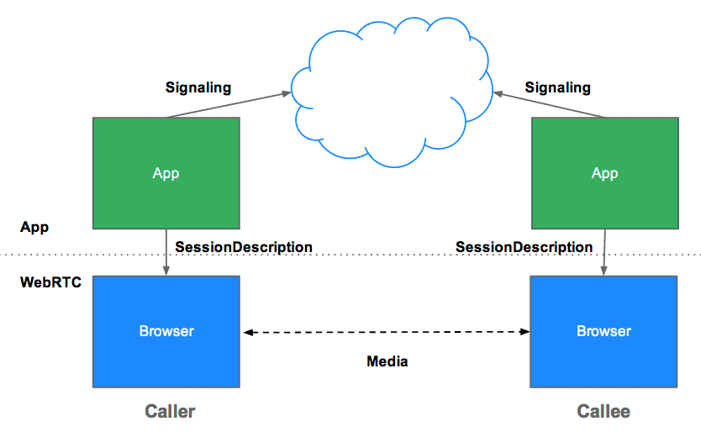
Mic Access
↓
Create PeerConnection
↓
Attach Audio Track
↓
Signaling (offer/answer)
↓
STUN discovery
↓
Encrypted audio flows
↓
Mute / Unmute
↓
Close connection

